October 2026

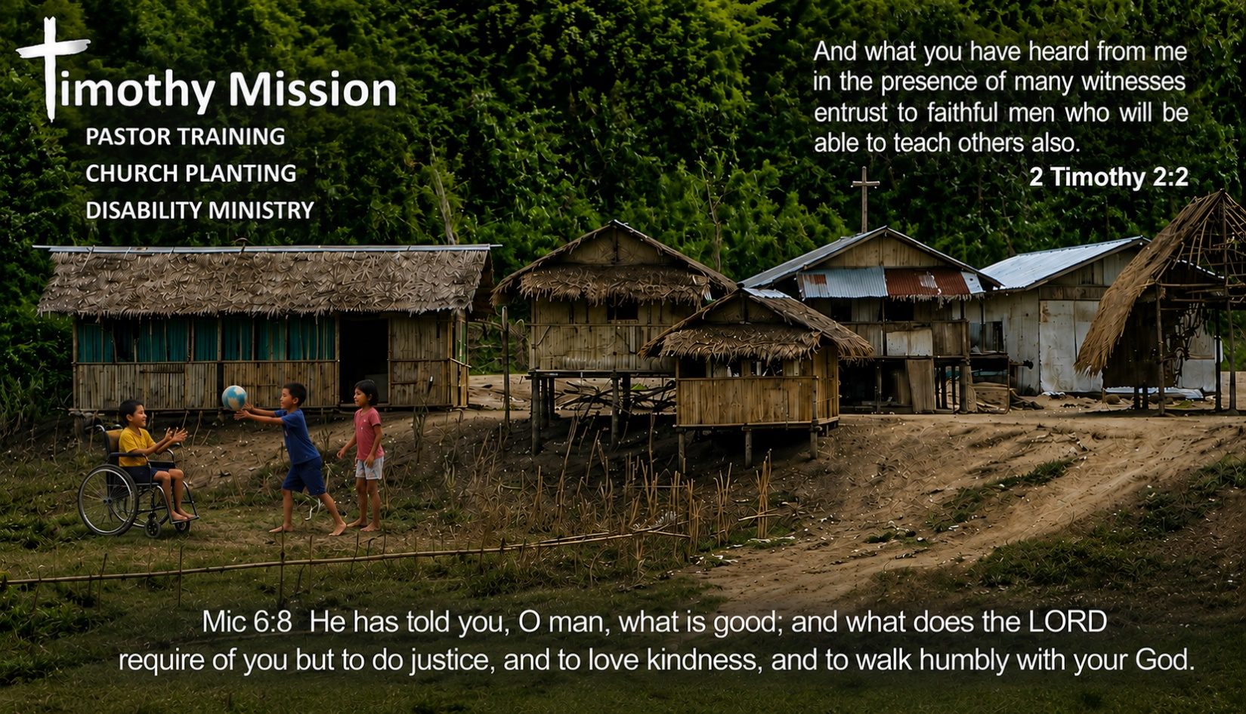

Videos of the Ministry

This month, I decided to give you a few short videos to view that will help you see where the ministry is and what it takes to b pull off some of the outreaches. I will also share two stories about children helped by the Children’s Recovery Unit.

First, videos of the tribal outreach.

This shows what it takes to get to some of the tribes, and the first class of Timothy Mission Bible school. The men desire to be pastors and reach other tribes. The women are spouses who want to know Scripture better.

https://youtu.be/zGTD8qibrZs If a single click does not make it play, hold the control key and click on the video.

This shows Pastor Rubio and some of his congregation holding an outreach in which food and the Truth of the Gospel are presented.

(Note: Ptr. Nikko mentions the Church of Christ Worldwide. It is not like the Church of Christ in the USA. Pastor Nikko's church uses the Five Solas as a guide, and is comfortable with pastors such as McArthur, and Begg.)

https://youtu.be/O-nh-pNjdz8

Videos of the Children's Village and inside the currentChildren’s Recovery Unit that we have outgrown and are working toward building a new place on the same location as the Children’s Village.

https://youtu.be/l1wd0BWX8fU

This is a short video of how one child, now grown up, was helped.

https://youtu.be/x64U2NIQw5U

Melanie’s Story
As told by my friend and co-laborer in the Lord, Claire Goudy Henderson

What makes a child whole?

“One day, a hospital asked me to come and see a newborn baby who needed a home.

When I pulled back the blanket, I discovered she had been born without hands, without feet, and without a mouth.

The doctor told me to take her home and let nature take its course.

Instead, I said:

‘I’ll take her home… and see what God does.’

So we took her home.

Our team fed her through a tube in her nose. We loved her. We prayed over her. And we believed that God had a purpose for her life.
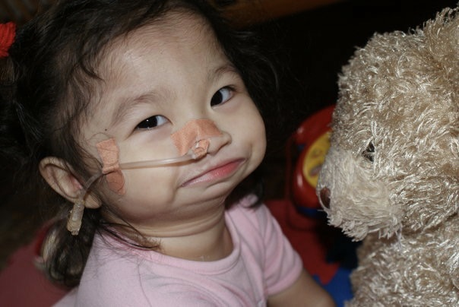

Years later, after surgery gave her a mouth, she entered an art competition.

The theme was:

‘What makes me whole?’

She didn’t draw her disability.

She drew a forever family.”

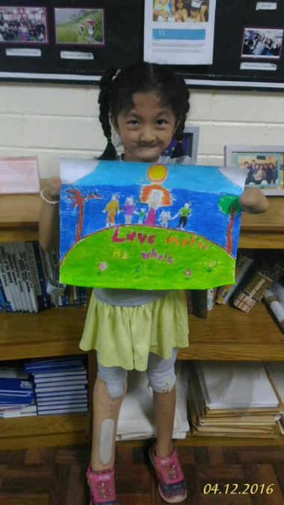

“She won first place nationally and third in the world

.

Soon afterwards, she was adopted into a loving family in America.

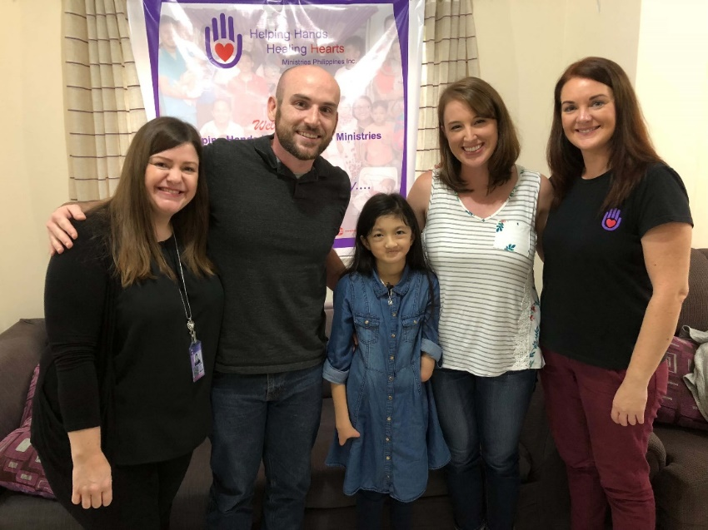

Today, she’s eighteen years old. She graduated from high school. She passed her driving test.
And she loves Jesus.”
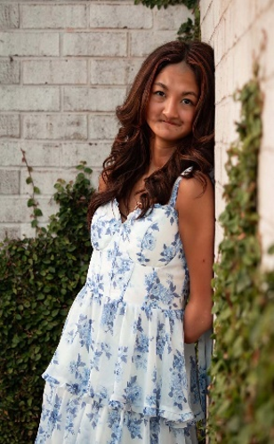

“That little girl is one of the reasons we are building the Children’s Recovery Unit.”

“Because Melanie’s story could have been very different.

She needed medical care.

She needed specialised feeding.

She needed surgery.

She needed therapy.

But she also needed something medicine alone could never give her.

She needed someone to believe that her life was worth fighting for.

And she needed a place where she belonged.”

That’s what we’re building.

A place where medically fragile children can receive excellent care without losing the experience of childhood.

The question was:

What makes me whole?

And Melanie didn’t draw hands.

She didn’t draw feet.

She didn’t draw a mouth.

She drew family.

“Melanie taught us something: sometimes healing isn’t about making a child look whole. It’s about helping a child discover that they already are.”

“Our job is not to define children by what is missing. Our job is to help them discover who they are, whose they are, and what they can become.”

When I look at her now, I don’t see a baby born without hands, feet or a mouth.

I see a young woman who knows she is loved.

I see a daughter.

I see possibility.

I see what can happen when someone says:

‘I’ll take her home… and see what God does.’”

Imagine what God could do for the next 40 children.

And there’s something even more powerful here

Melanie demonstrates why the Children’s Recovery Unit is not simply another medical facility.

She needed medical intervention, yes.

But the outcome wasn’t:

“We kept Melanie alive.”

The outcome was:

She became a daughter.

She got a family.

She got an education.

She developed a life.

She learned to drive.

She knows Jesus.

That is the difference between treatment and restoration.

CONTINUE

We don’t know what God will do with the life of every child who comes through our doors. But we want to make sure they have a safe place, excellent care, people who believe in them, and the opportunity to discover what God has planned for their lives.”

If you wish to help us be used by God to make more stories for kids like Melanie, train pastors, and plant true churches, please check the appropriate box and send this along with your check.
Please include a return address.

