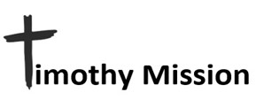
June 2025

PASTOR TRAINING - CHURCH PLANTING – DISABILITY MINISTRY

Ti 2:2 and what you have heard from me in the presence of many
witnesses entrust to faithful men, who will be able to teach others also.

More Church Construction
Nikko is one of my Timothys. I have told you before of how he has a passion for reaching the tribes scattered in the mountains, and how, as the village members come to faith in Christ, he desires to provide them with a “church” to protect them from the tropical sun and the torrential rains of the rainy season. They do not need to be fancy or large. This has resulted in an incredible thirteen churches. Number thirteen is shown on the left. But Nikko found another village, so you guessed it, number fourteen is in the works. The other two photos are Nikko and his wife loading up materials for number fourteen. The materials will be trucked to the base of the mountain, and then a team of volunteers will divide them up and hand carry them up into the mountains to the village.

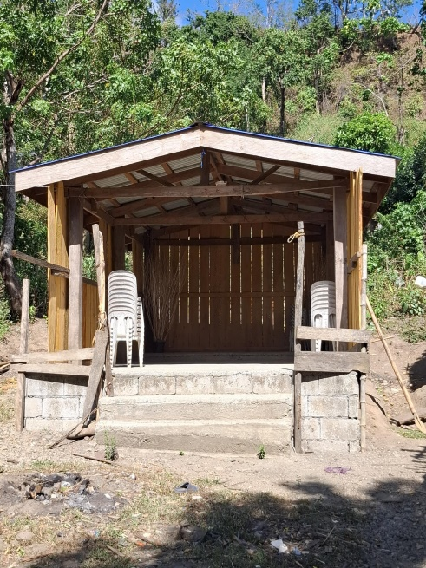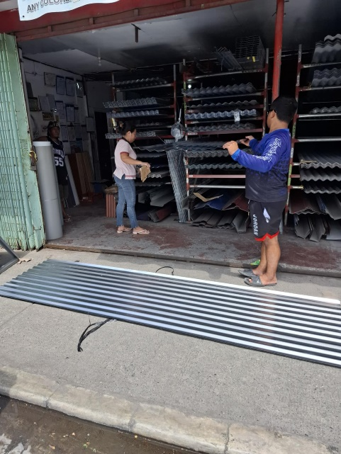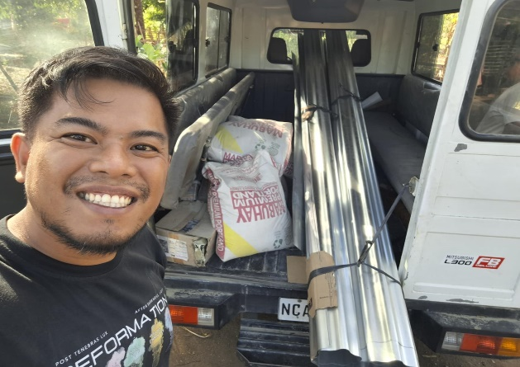

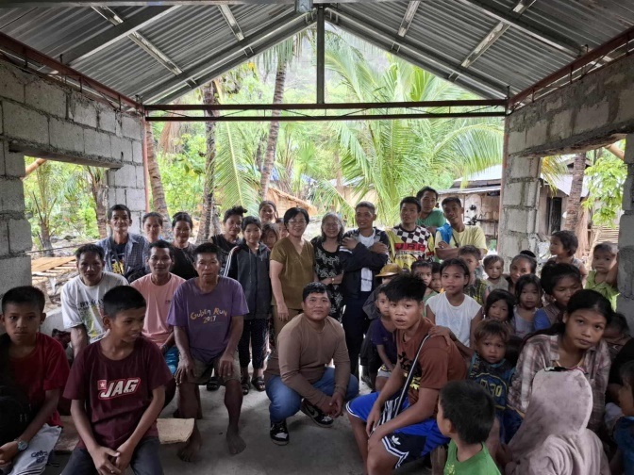
VBS

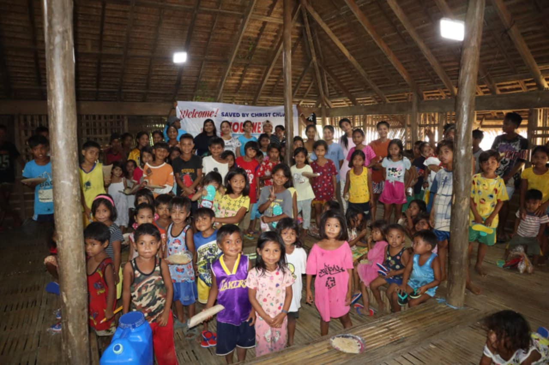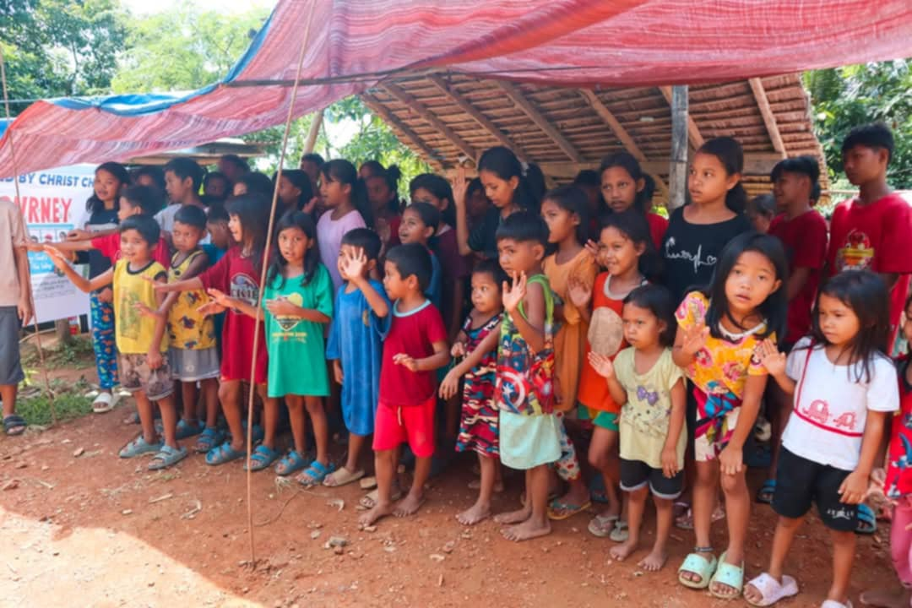

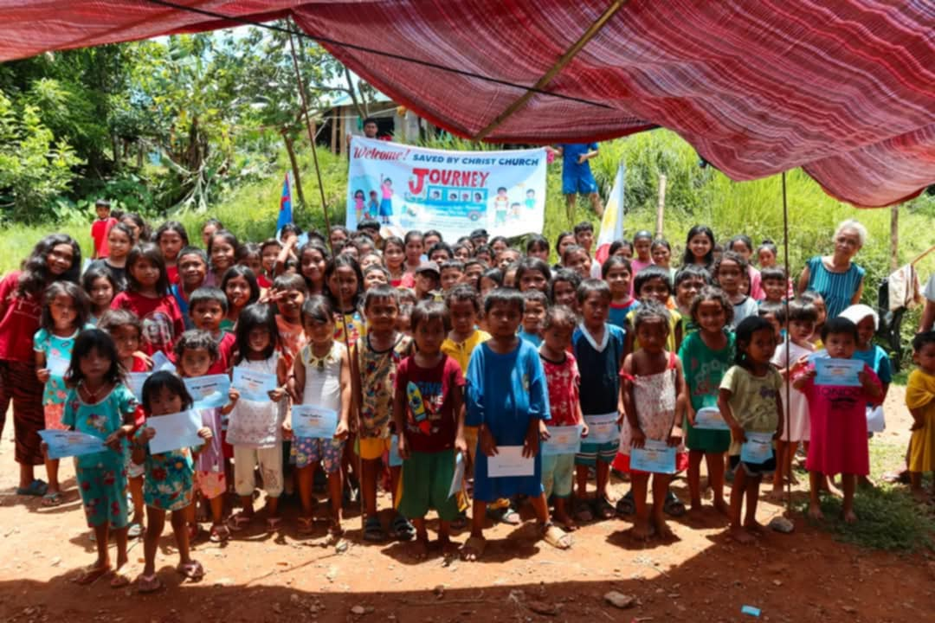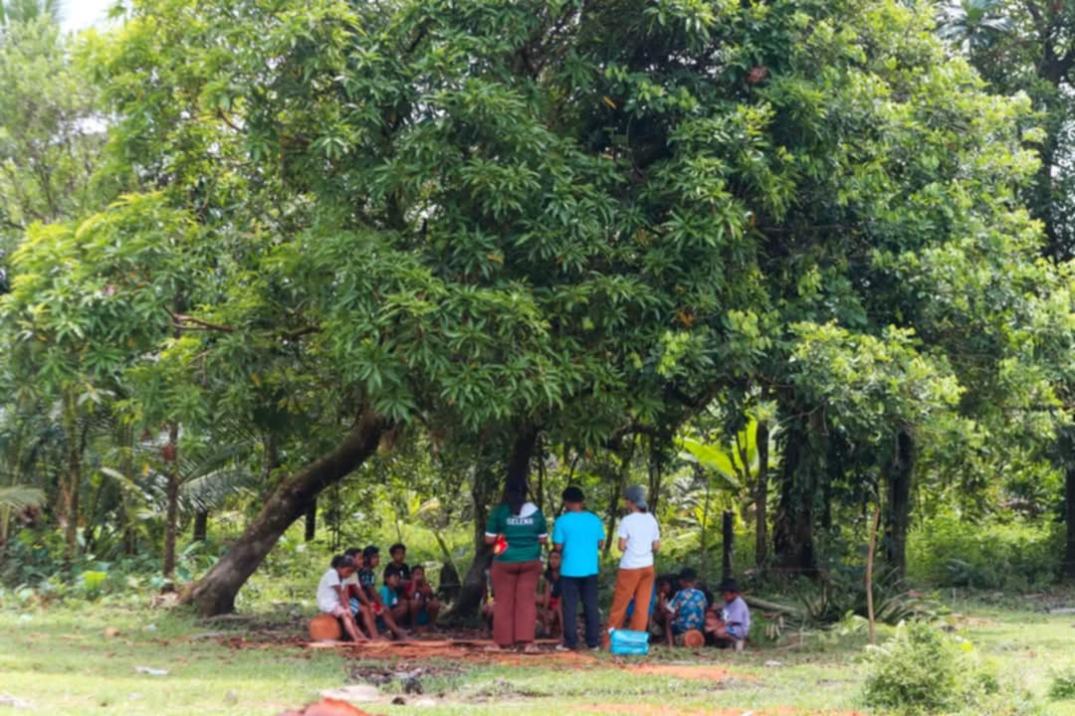

Kudos to those of you who volunteer to serve at your church's VBS. I understand how you find it very rewarding, but you are sometimes a bit tired by the end of the week. Consider this, both of my two teams on Mindoro held VBS at their churches. After that, they spent the next five weeks traveling to other villages of the island to do VBS again for the children in those places. Honest, each church held six VBS programs for six weeks straight. Many required long hikes into the mountains to get to the villages. They do it despite some unique challenges, such as the deadliest cobra in the world being in the Philippines, it can get very hot there in the summer, and there are active Communist rebels there. The VBS program includes providing a meal each day. We applied to an organization called Feed My Starving Children to receive food packets they produce for distribution by NGOs nationwide. We were accepted, and now they ship packets for the team to use. They now continue to arrive on a schedule, ensuring ongoing distributions. The packets contain rice fortified with soy to provide better nutrition than rice alone. Malnutrition is common in the Philippines, and this will be a big help to the people in the rural areas we serve.

More VBS

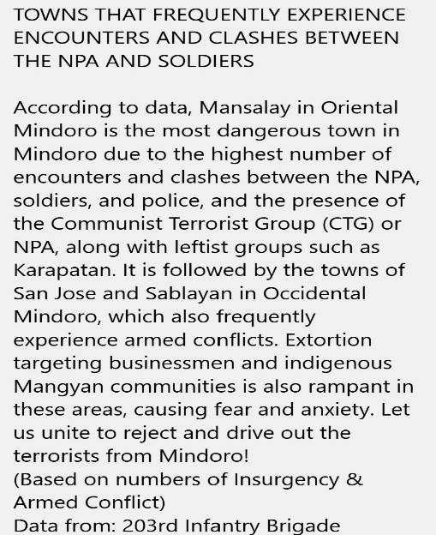
45C equals 113F

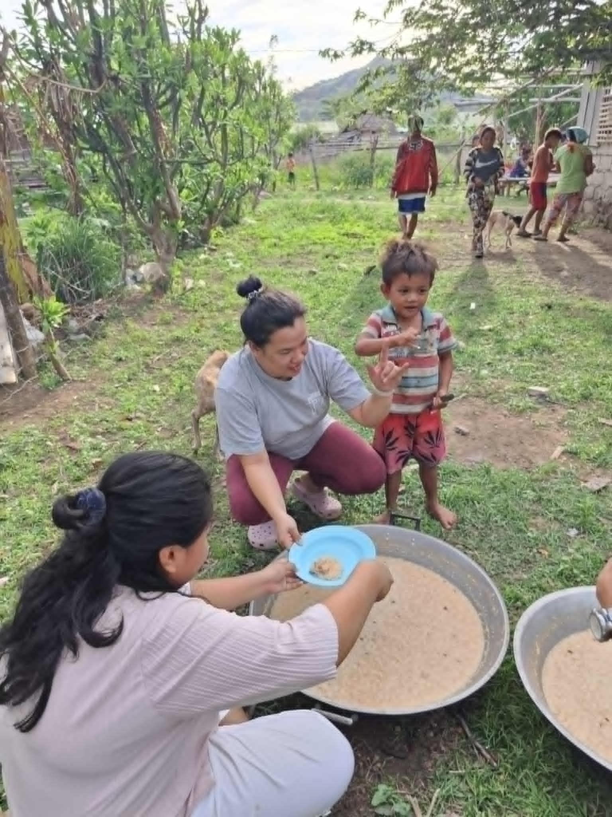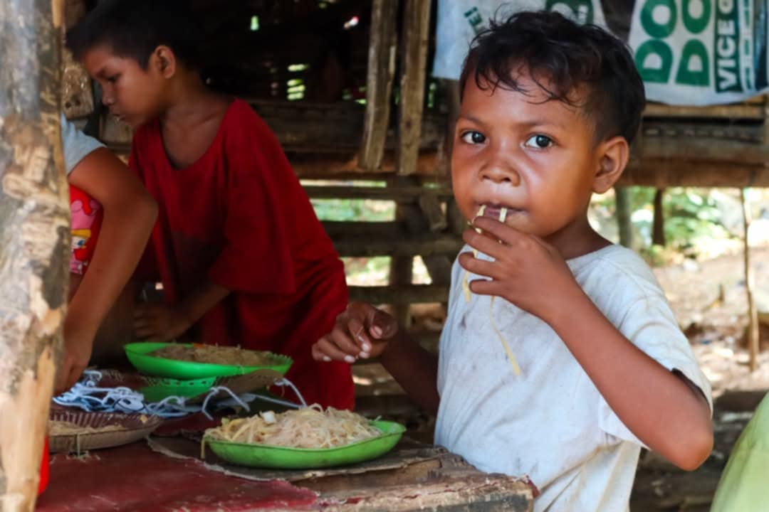
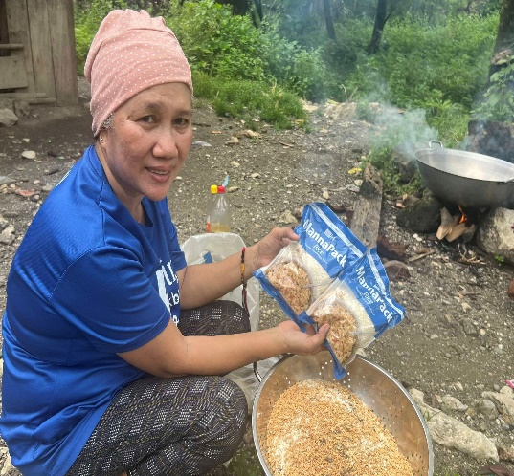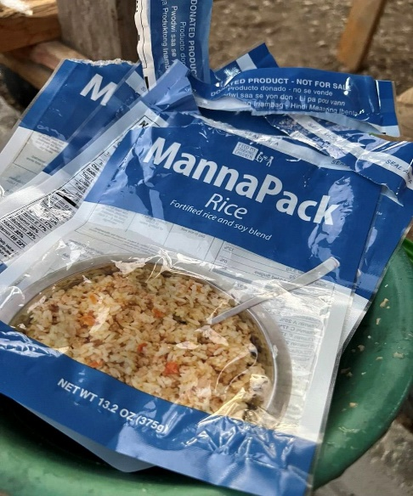

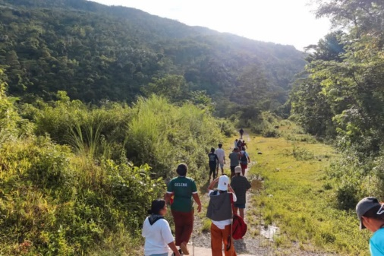
<<<Trekking in the mountains to reach another village and hold VBS

Summer Camp!

Yes, you read that correctly. After six weeks of VBS, the team in Naujan came home to do a Summer Camp program for the teens. It ran for four days and was an overnight camp with the participants sleeping on the church floor or under the stars. A guest preacher was brought in to do the teaching.

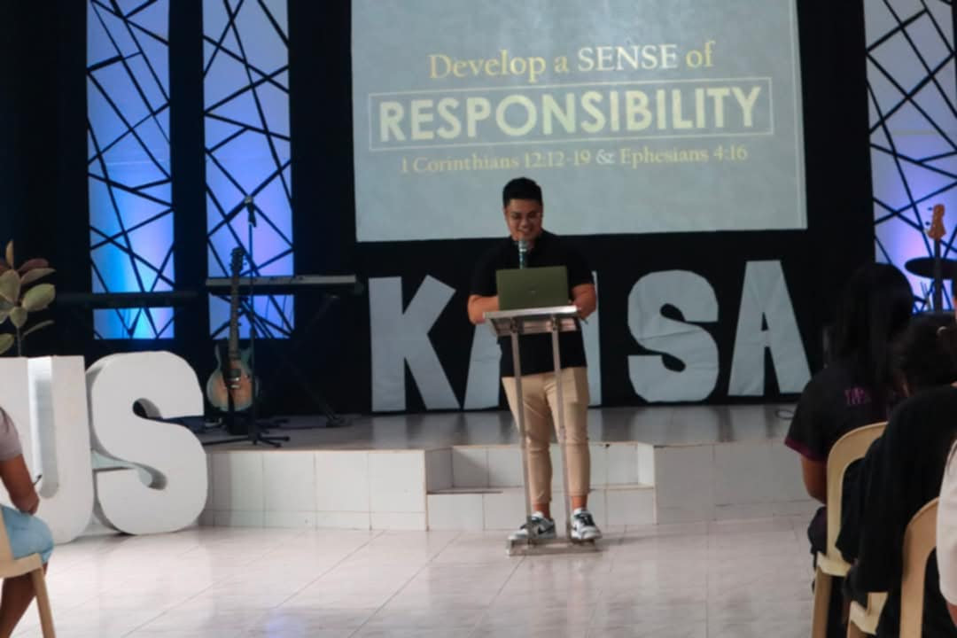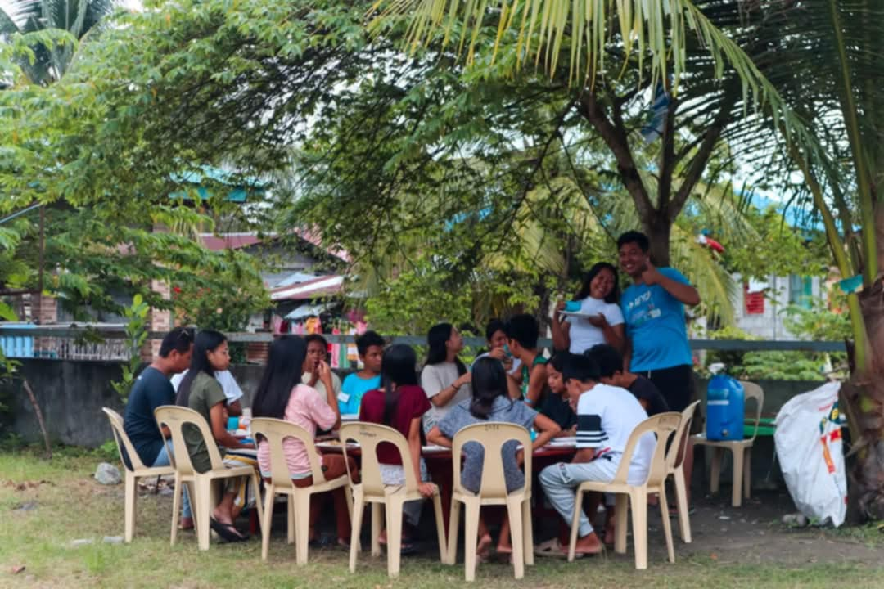

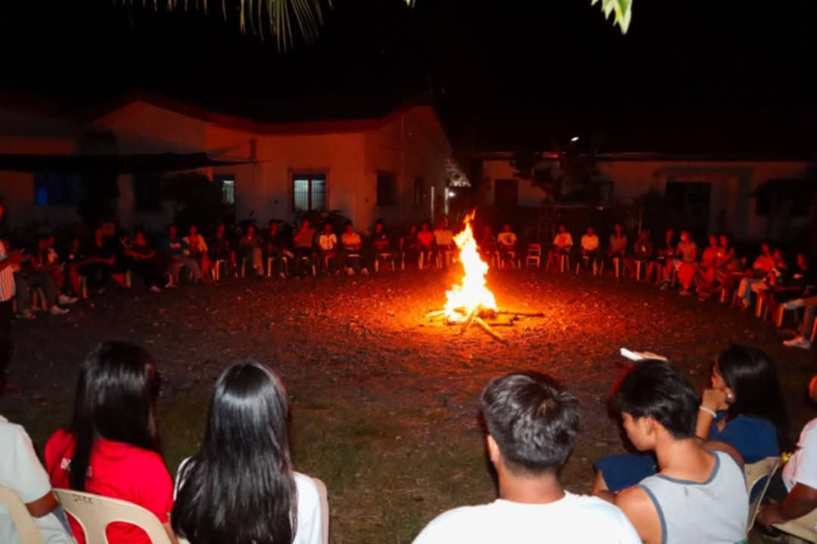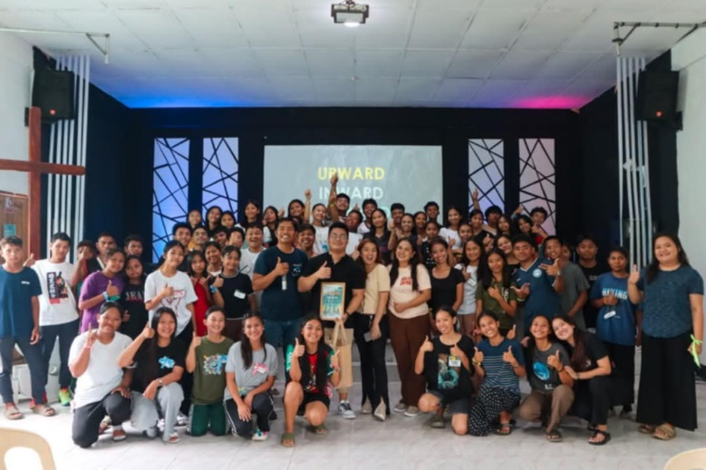

Pastor Training

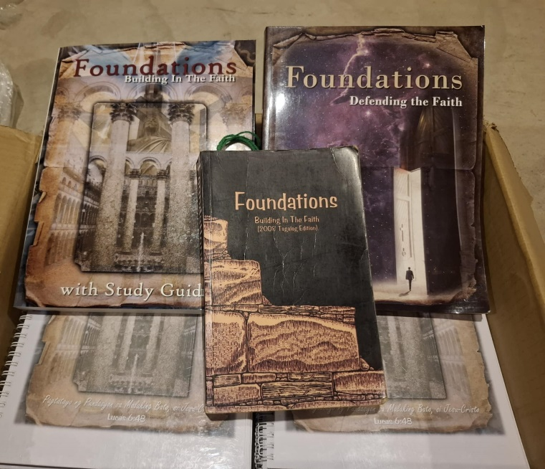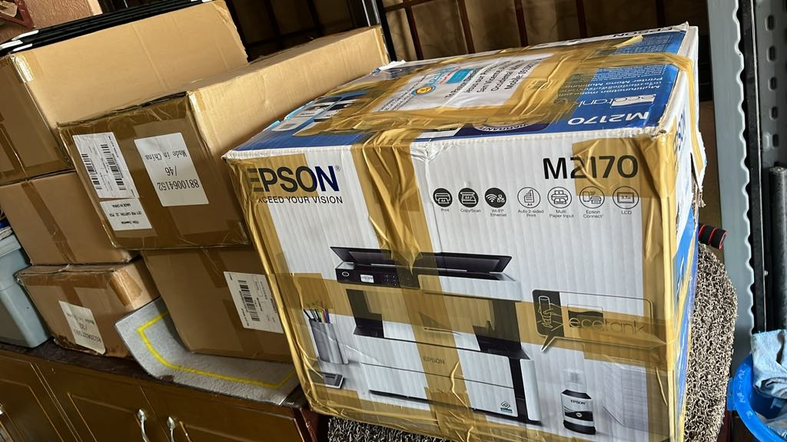

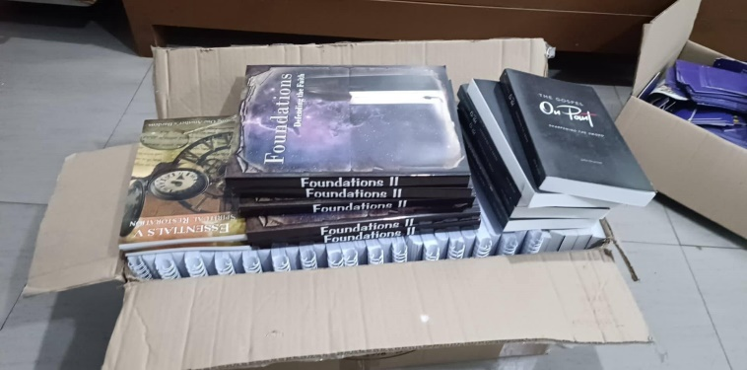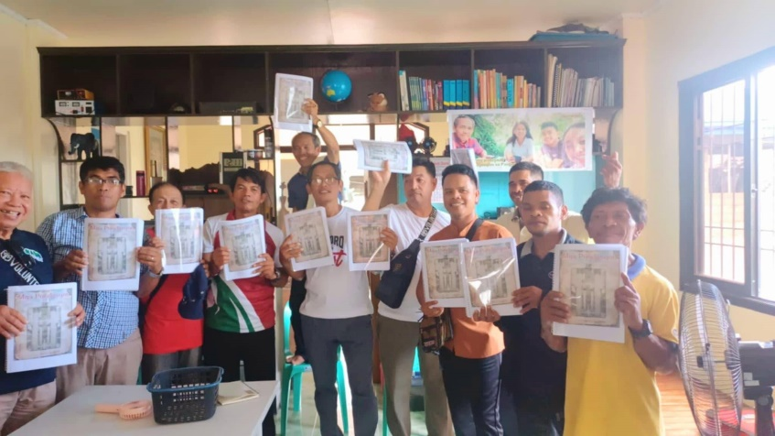

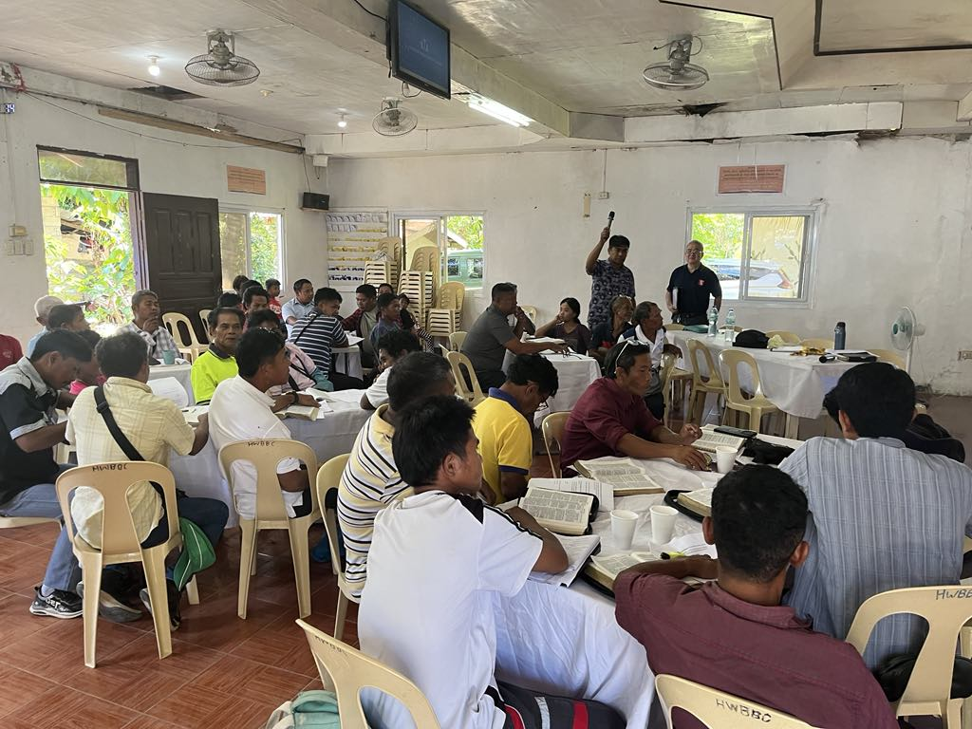
Pastor training is always ongoing, either via Zoom or by sending Pastor Ordeales to conduct classroom instruction. We currently offer a course in fundamental theology, utilizing the book Foundations, which is now available in Tagalog. I shipped this book and other titles to Mindoro, where Pastor Nikko distributed them. A total of 70 pastors were very happy to receive the book.

A Milestone
Mangyan Tribal Members Graduate High School

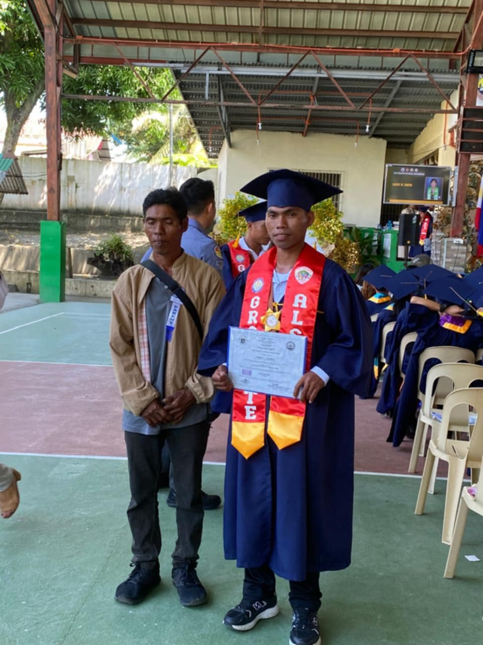
All that you have seen was made possible due to your support for Timothy Mission. If we did not exist, God would accomplish His will through someone else. But He chose us. Would you please help us to continue serving Him this way? You can use the form below to do so.
-----------------------------------------------------------------------------------------------------------------------------
__Support disability ministry.
__Church Planting / National Pastor Development and Support.
__As needed. (Mangyan outreach, evangelism materials. Bibles, medical care, etc.)
__ >Children’s Village project. The need for this is great and urgent. Special offerings above regular monthly support is our prayer. If donating please include a note stating what it is designated for.<

Make Checks payable to CMC and mail to:
Central Missionary Clearinghouse
P.O. Box 219228 Houston, TX 77218 For account: FORR MISSION AGENCY EMAIL : wjb700@earthlink.org
……………………………………………………………………………………………………………………………………………………………………………………..

“Go out quickly into the streets and lanes of the city and bring in here the poor and the maimed, and the lame and the blind. ….compel them to come in, so that my house may be filled. Luke 24: 21b, 23b

