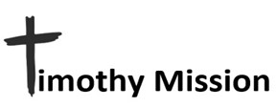
August 2024

PASTOR TRAINING - CHURCH PLANTING – DISABILITY MINISTRY

Ti 2:2 and what you have heard from me in the presence of many
witnesses entrust to faithful men, who will be able to teach others also.

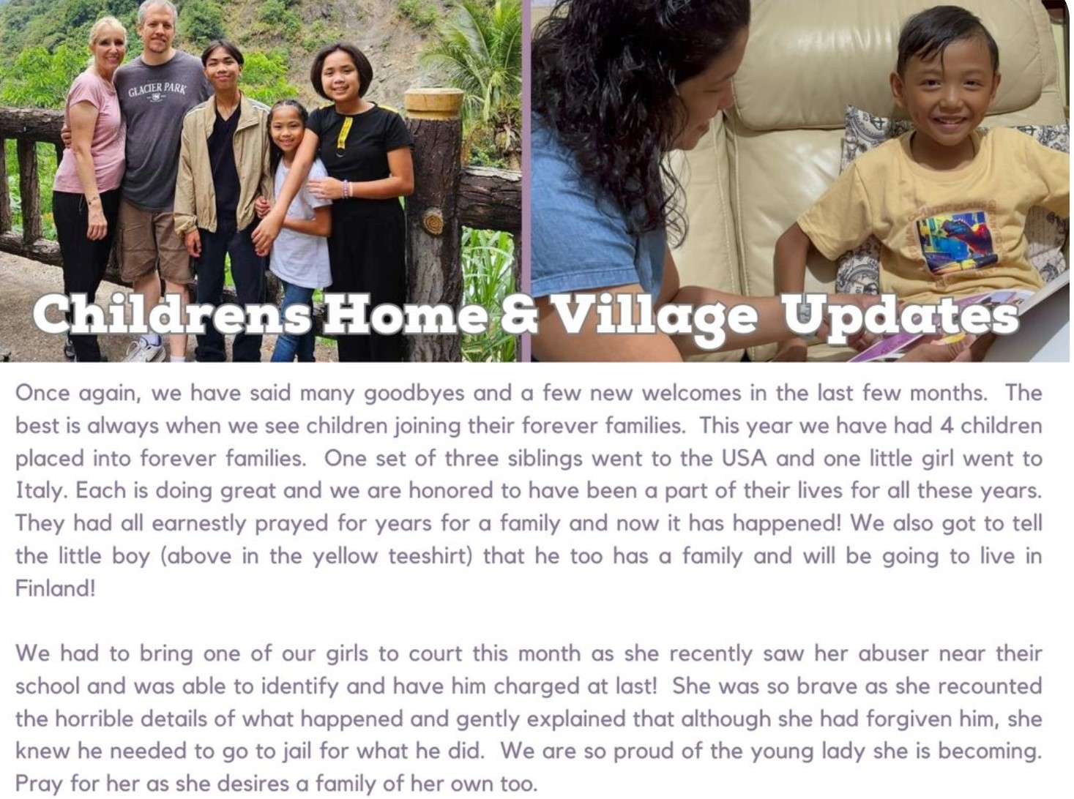

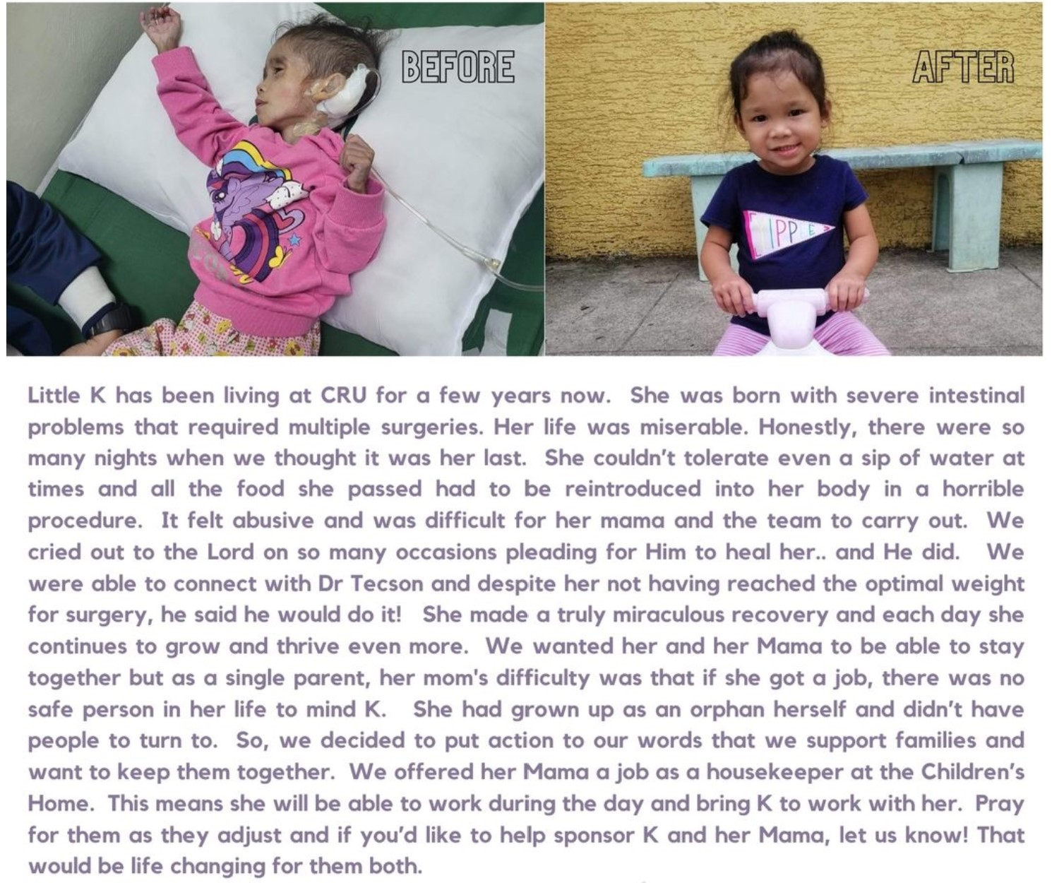

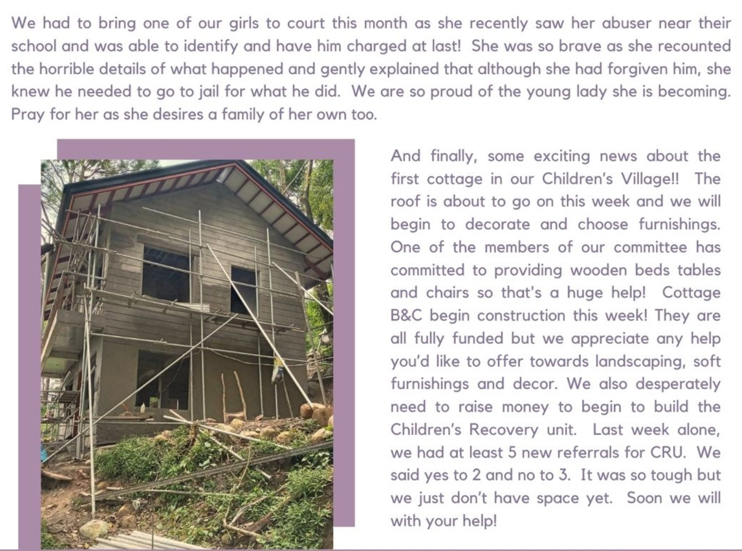

PASTOR TRAINING

Pastor Ordiales has completed another trip to remote areas of Mindoro to continue equipping pastors to handle the Word well and “rightly divide the Word of Truth” as the old English Bible says it. The lessons are in Romans, which is the basis for most of commonly understood theology. Below is a link to a video sent by Pastor Ordiales when he sent me his report of activities. The video mentions Timothy Mission, providing the pastors with some things for the pastors. Timothy Mission supports the entire operation, including the student's books, food during the study, shipping materials, and sea and ground transportation. This is in addition to, determining what is to be taught along with Pastor Ordiales, (Note, the water bottle with the Timothy Mission logo was Pastor Ordiales Idea. He went with the “it is easier to ask forgiveness then to get permission” philosophy. LOL) Please copy and paste this link into your browser. https://youtu.be/9U7as9d7Bo4

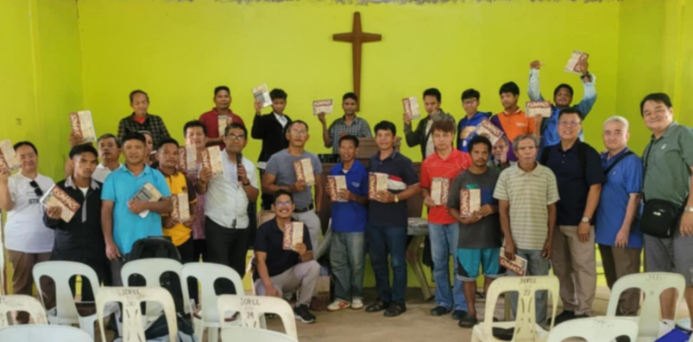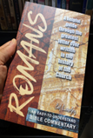
STUDENTS AND THEIR TEXTBOOK TO ACCOMPANY THEIR BIBLE,

Inflation is not a problem for our ministry over in the Philippines. The exchange rate between the USA and the Philippines absorbs it. Inflation tends to make some Americans more tight-fisted when donating to help others. Timothy Mission can only do the things you see in our newsletters with the help of people who care. Please consider making a one-time or monthly donation to the Lord’s work through Timothy Mission.

If you feel led to help, please cut out and use the form on the next page to send your gift. You will receive a tax-deductible receipt from CMC. Please check your designated use.
__Support disability ministry.
__Church Planting / National Pastor Development and Support.
__As needed. (Mangyan outreach, evangelism materials. Bibles, medical care, etc.)
__ >Children’s Village project. The need for this is great and urgent. Special offerings above regular monthly support is our prayer. If donating please include a note stating what it is designated for.<
__ Sponsor a family of four orphaned Mangyan children.
(This has been covered until April 2024 by a donor for one year! Thank you friends!)

Make Checks payable to CMC and mail to:
Central Missionary Clearinghouse
P.O. Box 219228 Houston, TX 77218 For account: FORR MISSION AGENCY EMAIL : wjb700@earthlink.org
……………………………………………………………………………………………………………………………………………………………………………………..

……………………………………………………………………………………………………………………………………………………………………………………..

“Go out quickly into the streets and lanes of the city and bring in here the poor and the maimed, and the lame and the blind. ….compel them to come in, so that my house may be filled. Luke 24: 21b, 23b

