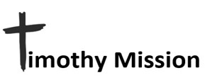
April 2024

PASTOR TRAINING - CHURCH PLANTING – DISABILITY MINISTRY

Ti 2:2 and what you have heard from me in the presence of many
witnesses entrust to faithful men, who will be able to teach others also.

Pastor Training for 2024 is Underway.
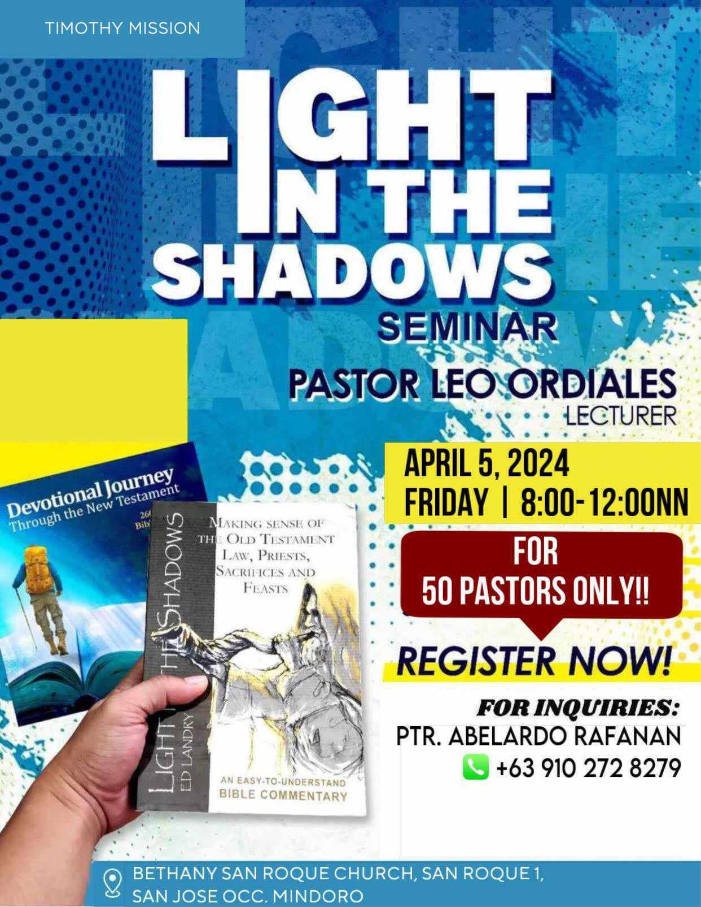

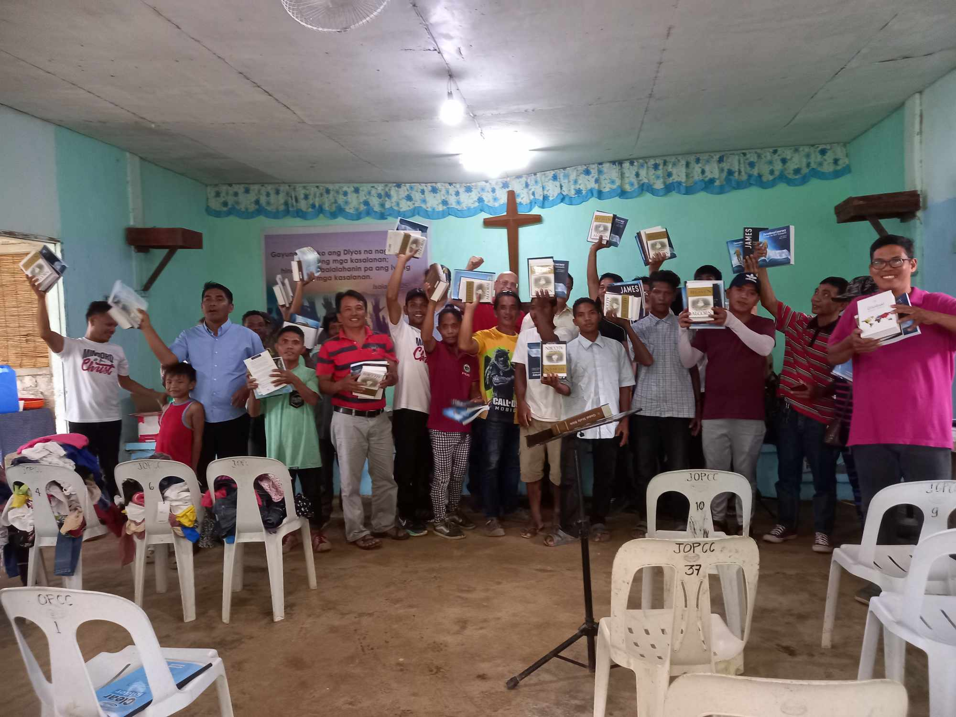
Some of the pastors that received teaching in Old Testament
and it’s prophecies of Christ the Messiah.

Pastor Leo has returned from the first training session with indigenous pastors. As you can see from the photo they are always happy to learn the Word more deeply so that they can teach their flocks well. We are already in discussions about the next training I will send Pastor Leo to do. The following quote will show you why I am happy to work shoulder to shoulder with him in training pastors.

“We can be assured that all of Scriptures is inspired and inerrant. The purpose is absolutely prescribed and designed to honor God by his truth. I believe the Scripture alone if expounded rightfully and empowered by the Holy Spirit can fulfill its purpose, it will not return void. Isaiah 55:11; Hebrews 4:12.
I will encourage our pastors to be trained well in it: not by telling so much testimonies, illustrations, jokes, opinions, etc. Nothing should overshadow the Scriptures on the pulpit.” Pastor Leo C. Ordiales

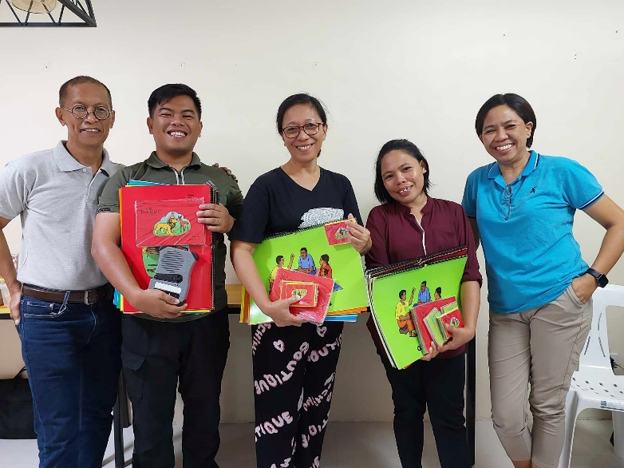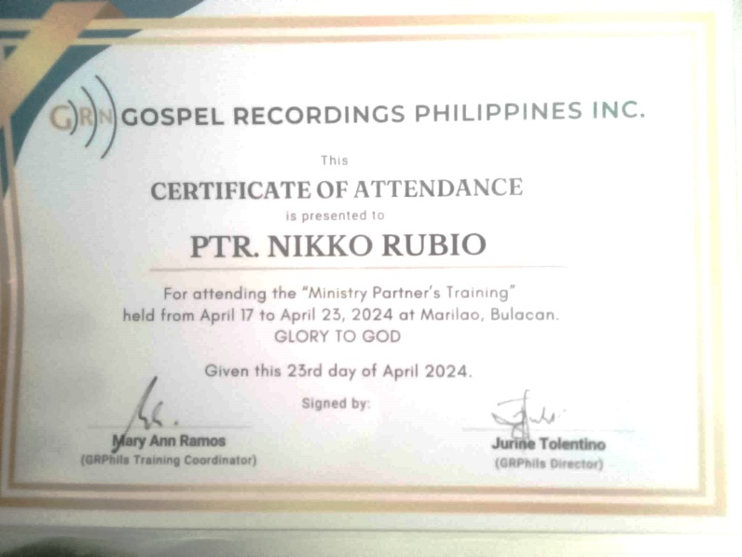
Through your support I was able to send Pastor Rubio, ( second from the left) our newest pastor serving in southwest Mindoro to the Main Island of Luzon for training in how to develop Bible teaching materials for the tribes in their own language. Pastor Rubio has a strong desire to minister to the tribes in the mountains of his area and makes trips to them often, in spite of the fact that the Communist rebels up there have threatened his life. Here you see him holding the audio Bible he was given along with visual aids for teaching children. I showed you in past prayer letters the audio Bible when we provided one to our team working in the Naujan area of Mindoro. The device is charged by a built-in hand cranked generator and has Bible lessons in addition to the Bible itself. It is in the language of the tribe. In the Naujan area we were able to train a Mangyan tribesman to use the materials and he makes regularly scheduled trips into the mountains to use the device with the tribes there.
If you feel led to help, please cut out and use the form on the next page to send your gift. You will receive a tax-deductible receipt from CMC. Please check your designated use.
__Support disability ministry.
__Church Planting / National Pastor Development and Support.
__As needed. (Mangyan outreach, evangelism materials. Bibles, medical care, etc.)
__ >Children’s Village project. The need for this is great and urgent. Special offerings above regular monthly support is our prayer. If donating please include a note stating what it is designated for.<
__ Sponsor a family of four orphaned Mangyan children.
(This has been covered until April 2024 by a donor for one year! Thank you friends!)

Make Checks payable to CMC and mail to:
Central Missionary Clearinghouse
P.O. Box 219228 Houston, TX 77218 For account: FORR MISSION AGENCY EMAIL : wjb700@earthlink.org
……………………………………………………………………………………………………………………………………………………………………………………..

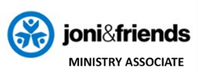
Go out quickly into the streets and lanes of the city and bring in here the poor and the maimed, and the lame and the blind. ….compel them to come in, so that my house may be filled. Luke 24: 21b, 23b

