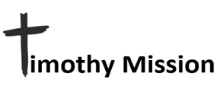
October 2023
PASTOR TRAINING - CHURCH PLANTING – DISABILITY MINISTRY

We have gotten the various ministries in the field to stand on their own more and more. It is not that they did not have their own motivation to do so, they simply needed the means to do so. The farming, for their food and income for medical needs as they arise, is beginning to show good results. Without the support that came from you through Timothy Mission to obtain land, farm equipment, and seed, they would not have had the means to get started. Without Bibles, study materials, audio Bibles to use with the tribes, and training provided by you through Timothy Mission they would not have been able to plant the five churches now in place. Without financial support from Timothy Mission, the pastors of the five churches ability to support their families would not be possible. Even so, we deliberately do not provide each man with full support. We want the people to learn that the church needs to support their pastor. We no longer support one of the pastors because his church has grown to where they have taken on 100% of his support.
Each church is directly accountable to Timothy Mission and in addition to reports given to me directly from the pastors, Pastor Ordiales is our boots on the ground, eyes on man there for that purpose. But I felt we should get the various churches themselves to report to you on their ministries from time to time. So, the following are prayer letters produced by two of the churches. The first is from Saved By Christ Church in a neighborhood (Barangay) of Naujan called Santiago. It is the first church we helped plant. The second is within the boundaries of Naujan but like many of the 70 Barangays of Naujan it is out in the boondocks. It is called Sta. Isabel.


Go out quickly into the streets and lanes of the city and bring in here the poor and the maimed, and the lame and the blind. .compel them to come in, so that my house may be filled. Luke 24: 21b, 23b
MINISTRY ASSOCIATE
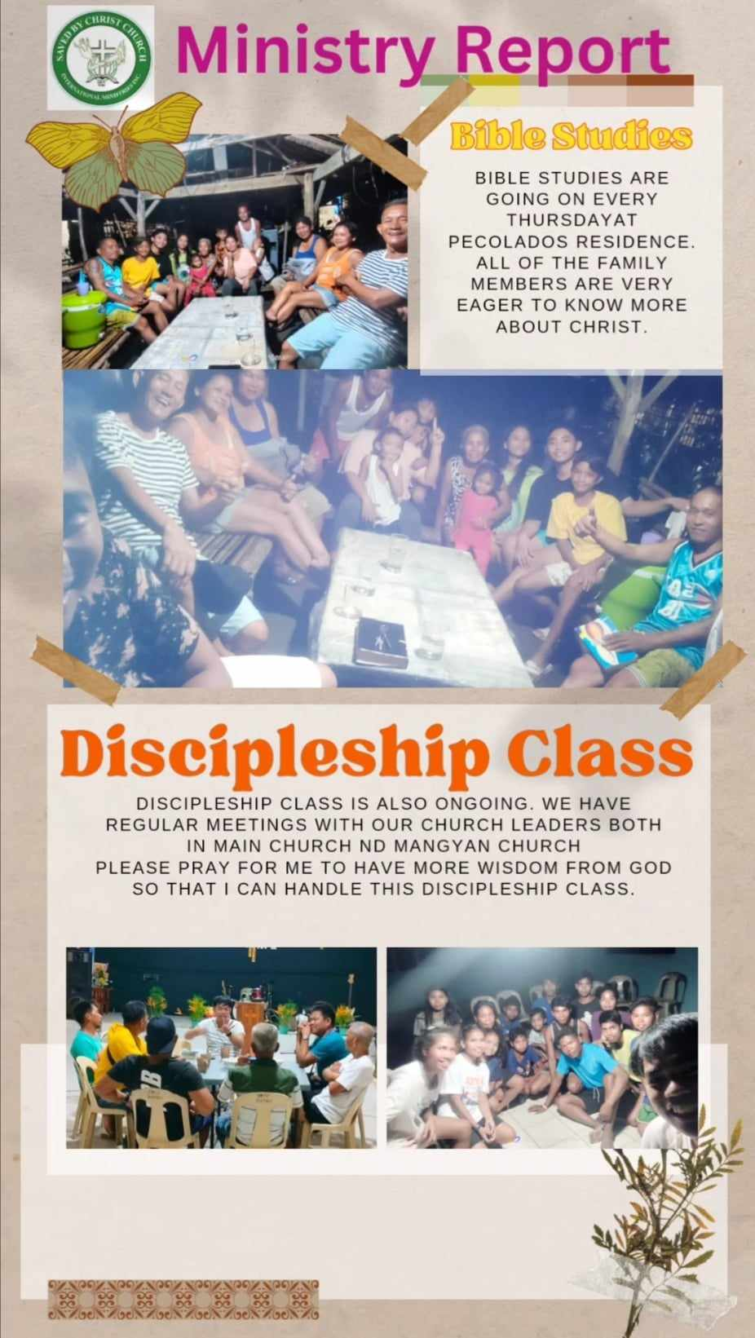
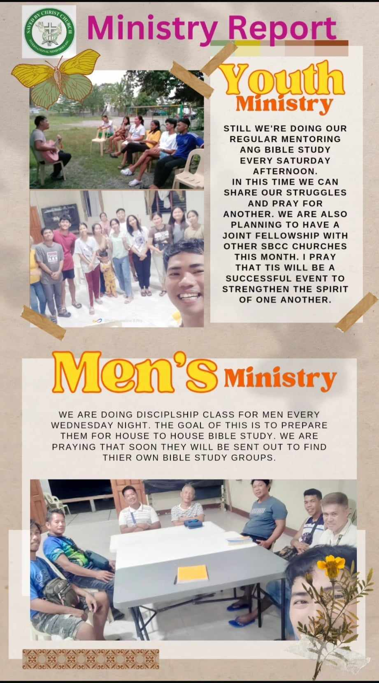
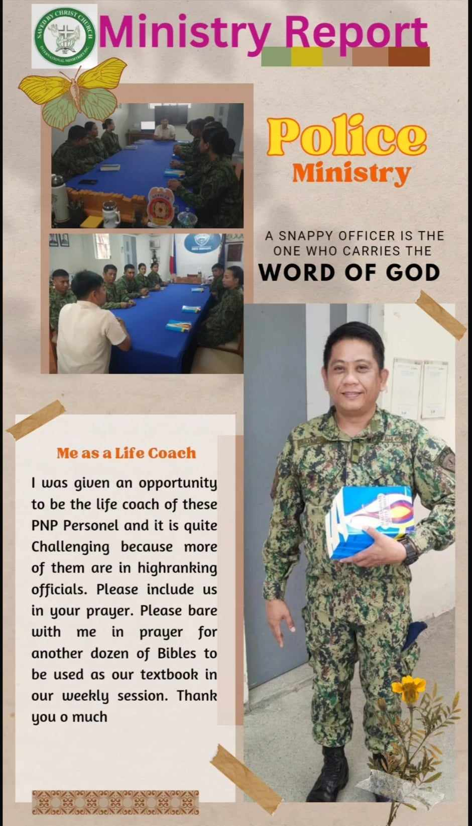
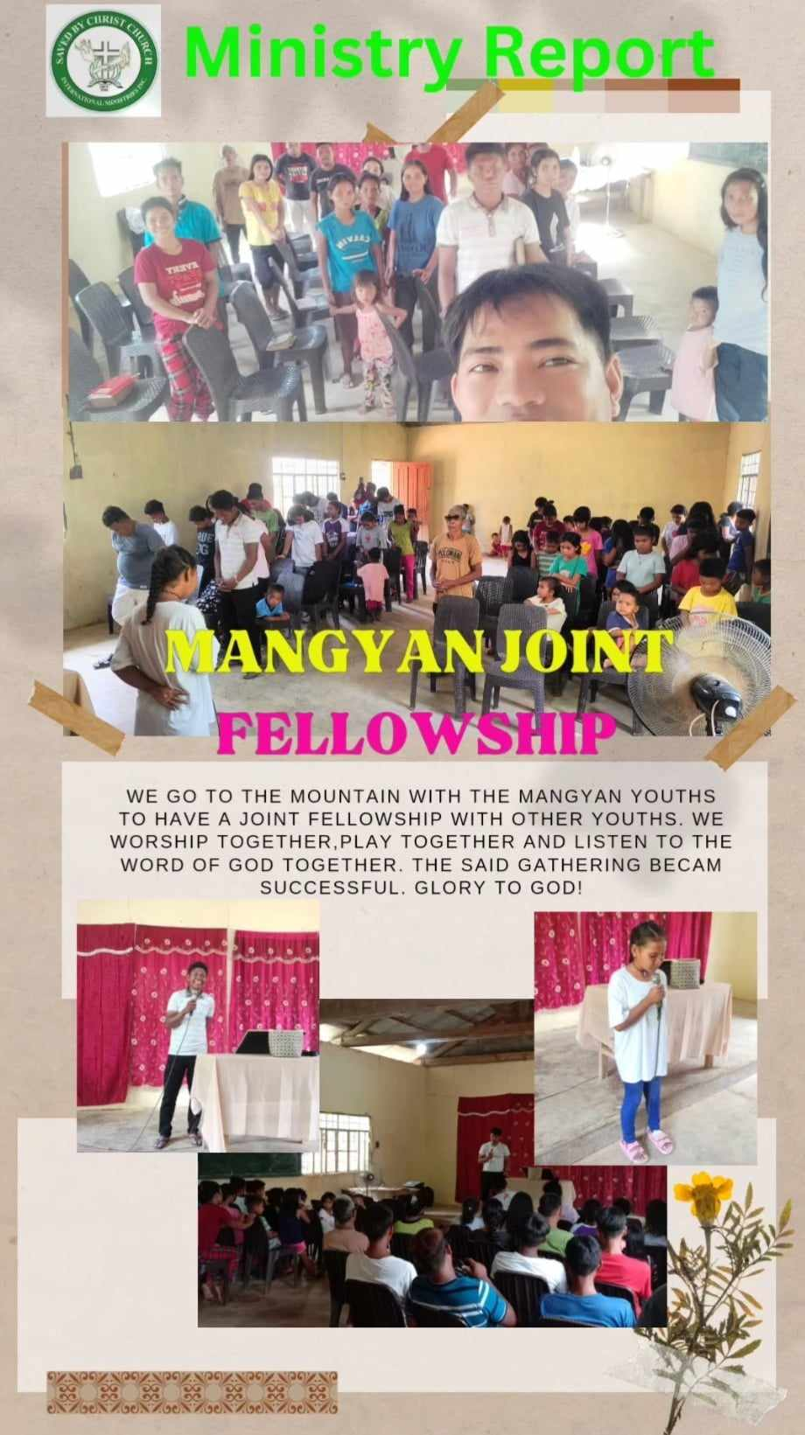
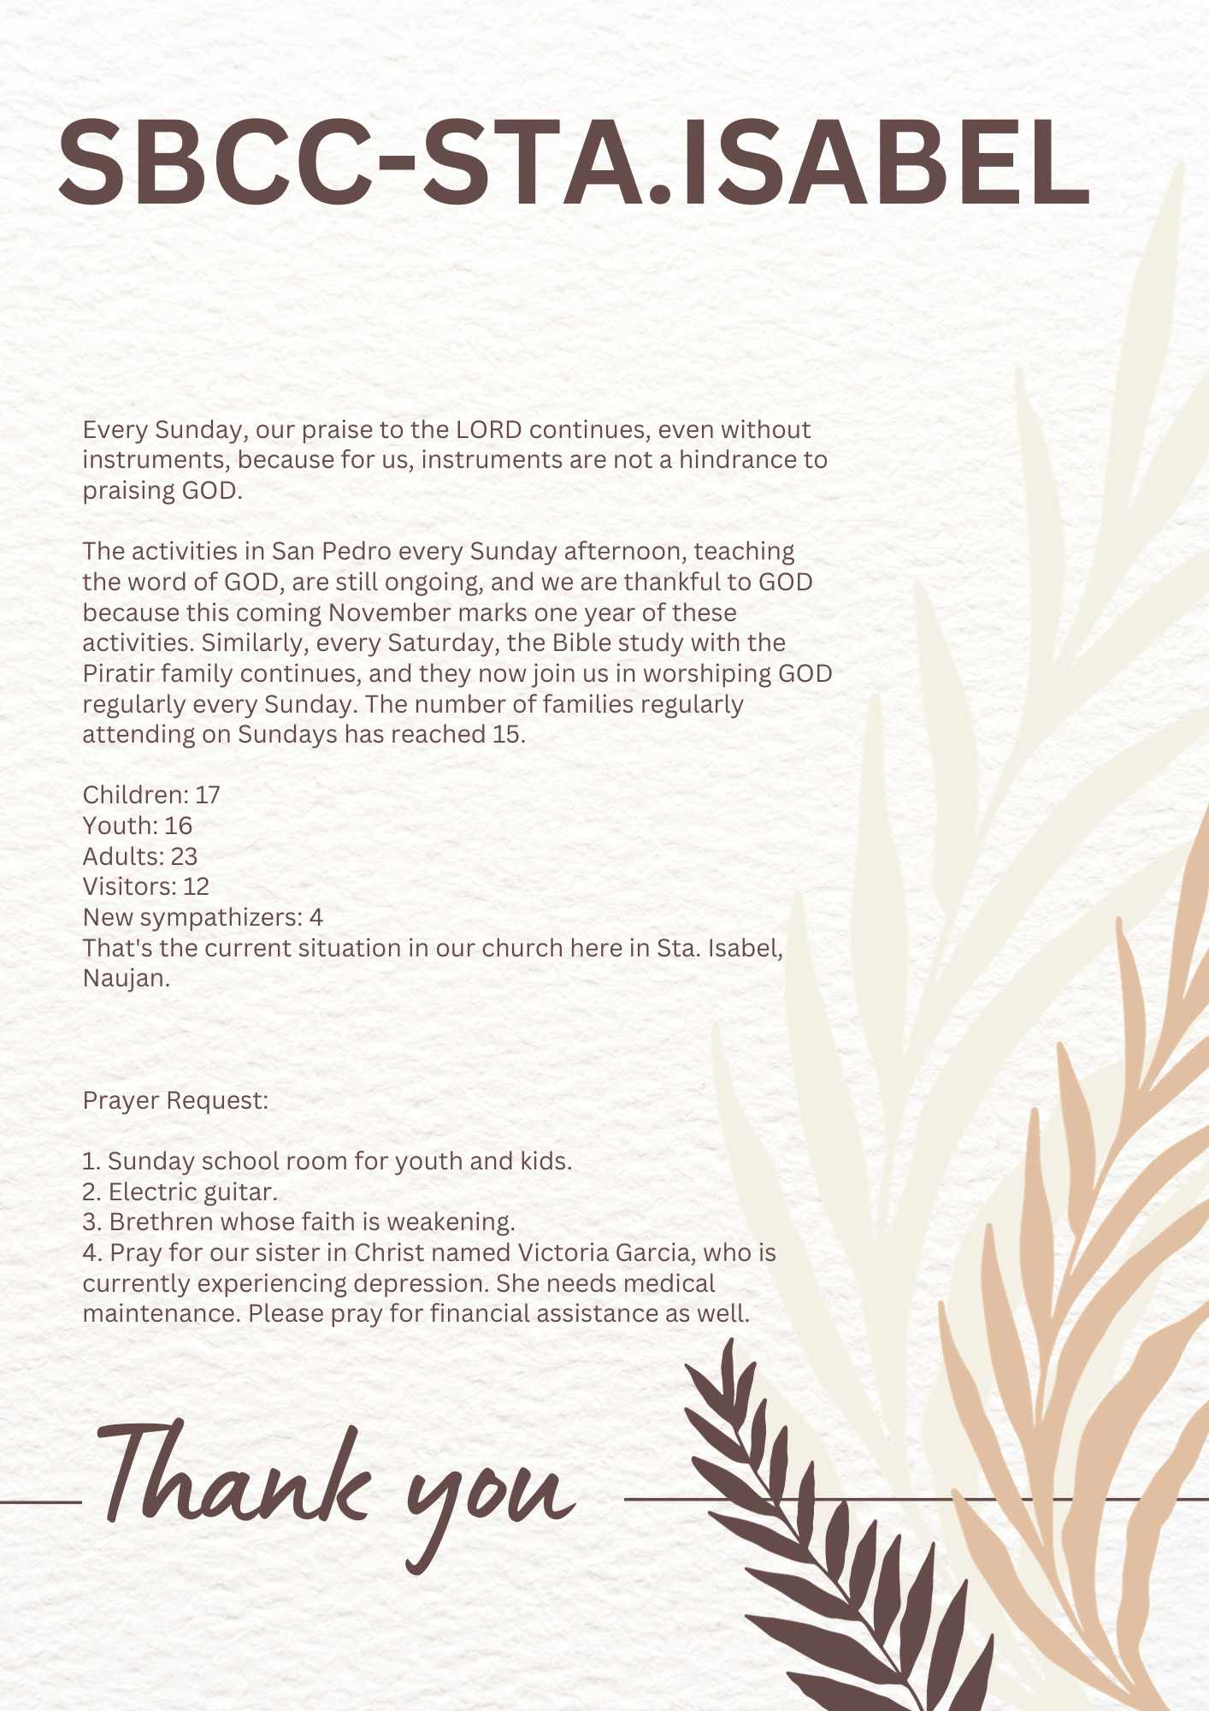
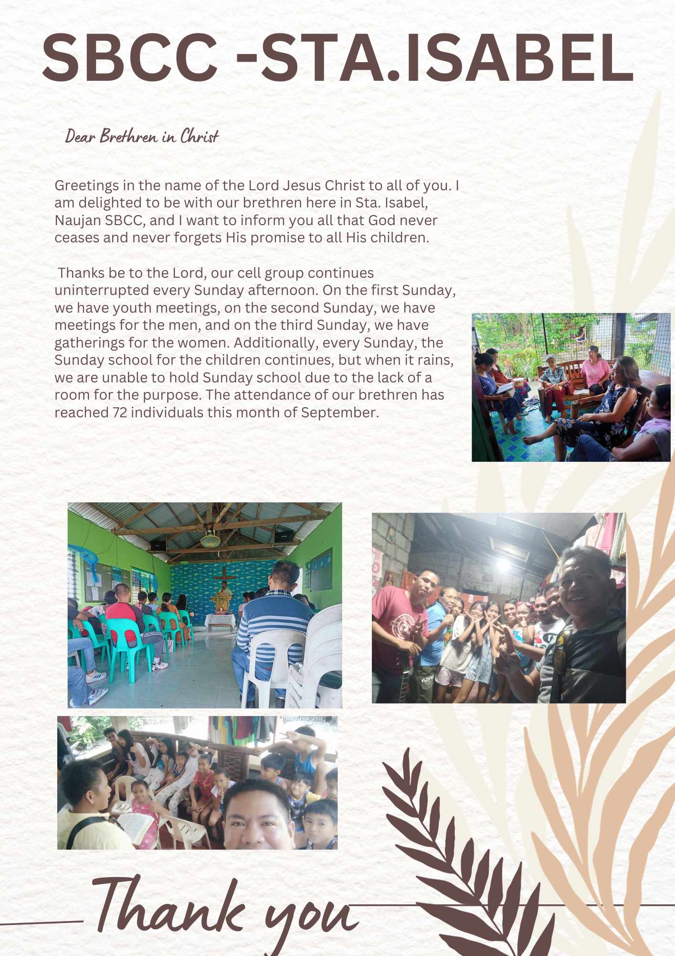

If you feel led to help, please cut out and use this section to send your gift. You will receive a tax-deductible receipt from CMC. Please check your designated use.
__Support disability ministry.
__Church Planting / National Pastor Development and Support.
__As needed. (Mangyan outreach, evangelism materials. Bibles, medical care, etc.)
__ Children’s Village project.
__YOU MAY ENTER HERE SOMETHING OF YOUR OWN THAT YOU WOULD LIKE TO SPECIFY YOUR GIFT TO GO TO.
______________________________________________________________________________________________
__ Sponsor a family of four orphaned Mangyan children. (This has been covered until April 2024 by a donor for one year! Thank you friends!)
Make Checks payable to CMC and mail to:
Central Missionary Clearinghouse
P.O. Box 219228 Houston, TX 77218 For account: FORR

